|  | **Pimpri Chinchwad Education Trust’s**  **Pimpri Chinchwad College of Engineering & Research Ravet, Pune** An Autonomous Institute | NBA Accredited (4 UG Programs) | NAAC A++ Accredited | An ISO 21001:2018 Certified  **IQAC PCCOER** |  |
| --- | --- | --- |
| **Academic Year:** 2025-26 | **CEP Project Synopsis** | **Term – I** |

**Date:**

| **Project Title** | **Student Cart** |
| --- | --- |
| **Group ID** | E7 |
| **Student Name**  **(with roll no)** | **SECOE64-Pranav Shegokar SECOE66-Yash Shelar**  **SECOE67-Omkar Shinde SECOE51-Sanchet Pawar** |
| **Guide Name** | **Shivganga V Ghavane** |
| **Abstract** | |

**As student costs rise, coupled with tight financial constraints and immediate necessities, there's been an enhanced desire for cost-effective materials. Traditional retail stores and digital markets frequently overlook student-specific needs like cost-effectiveness, reliability, and simplicity in connecting them locally.**

**The objective is to create an educational platform where students can buy used items and**

**sell them again, encouraging recycling and environmental responsibility specifically tailored to meet their requirements.**

**Addressing student affordability and access challenges via an exclusive used goods store**

**stems from the urgent desire to alleviate economic pressures while promoting eco-friendly methods. Today's demanding and competitive setting has revealed shortcomings in conventional shopping networks for consumers like college students, who require features including price competitiveness, reliability, and collaborative exchanges within communities. The endeavor focuses on developing an efficient system designed for both teachers and learners, emphasizing sustainability through reusability while reducing environmental impact and enhancing educational accessibility.**

**ARCHITECTURE**

Rev.: 00 Date: 01-09-2024 Page **1** of **3**

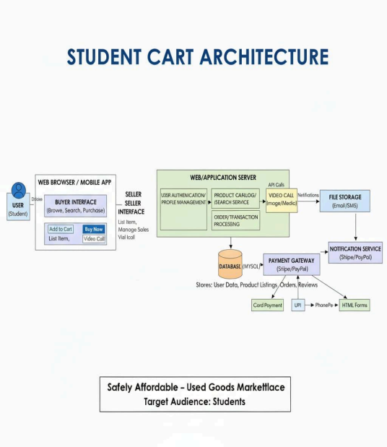Rev.: 00 Date: 01-09-2024 Page **2** of **3**

❖ **Students can acquire necessary goods more affordably, thereby reducing their economic pressures.**

❖ **Encouraging reusing items minimizes waste while fostering environmentally friendly methods.**

**Building trust through engagement among peers minimizes external interactions in educational settings.**

❖ **The convenience offers users access to a user-friendly system where they can effortlessly post listings, find products quickly, and make purchases easily. resource management prevents surplus materials from going unused by redirecting efficient them towards more suitable applications rather than discarding them.**



**.A student-focused platform offering functionalities like item posting, searching/filtering tools, account creation for users, and safeguarded payments effectively tackles current educational funding issues among learners. This system cuts costs while encouraging responsible use of items by students, fostering trust within this group, thereby providing an economically beneficial, user-friendly educational experience for learners**

**Signature of Students Signature of Guide** Rev.: 00 Date: 01-09-2024 Page **3** of **3**